**Version 1.1**

CPAQuiz Administration Manual

08

**Fall**

Table of Contents

1 Login and Logout 3

2 Create A New User 4

3 Manage Profile Fields 5

CPAQuiz Administration Manual

# Login and Logout

When CPAQuiz URL is entered on your browser, a login page will be shown up, for example:

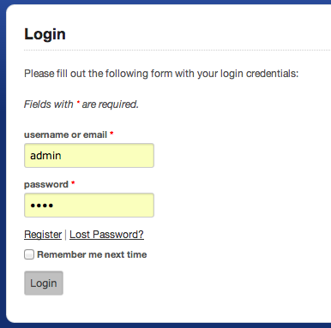

CPAQuiz comes up with two sample users with the following info:

* Username **admin** , password **1234**. This user has root permission that can access all modules: the administration pages and the auto responder pages.
* Username **daniel**, password **1234**. This user has regular user permission that can’t access the administration pages.

Click **Login** button to login to the system. You can see the main menu bar on top, and the main dashboard.

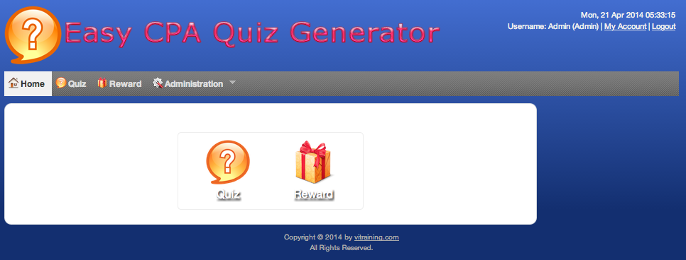

Please refer to the *User Manual Documentation* on how to use and utilize all the modules.

To Logout from the system, simply click on the **Logout (username)** link on the menu bar. You will be logged out and back to the login form.

# Create A New User

If logged as admin user, you can see the users list and create new users on the system.

Click on the Menu **Administration 🡪 Users** to see the users list and create new user.

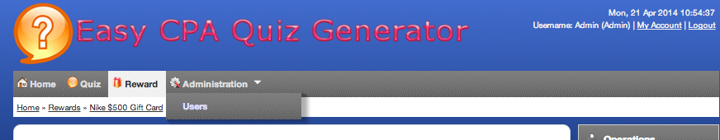

A new page is shown as follow:

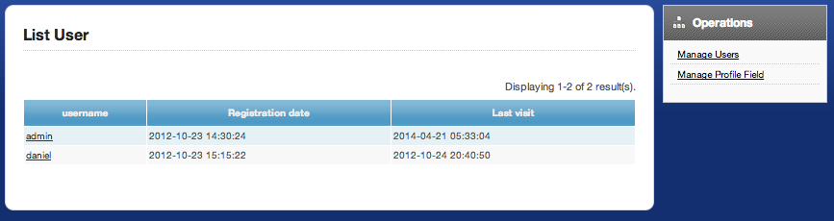

Click on the Manage Users link on the Operations box at the right of the page.

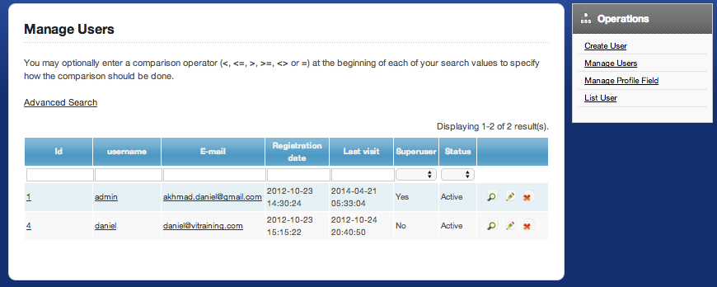

On that page you can see the existing users on the system. It shows the username, user’s group, email, full name, and the status.

To create a new user click on the **Create User** link on the top of the page. A page like the following will show.

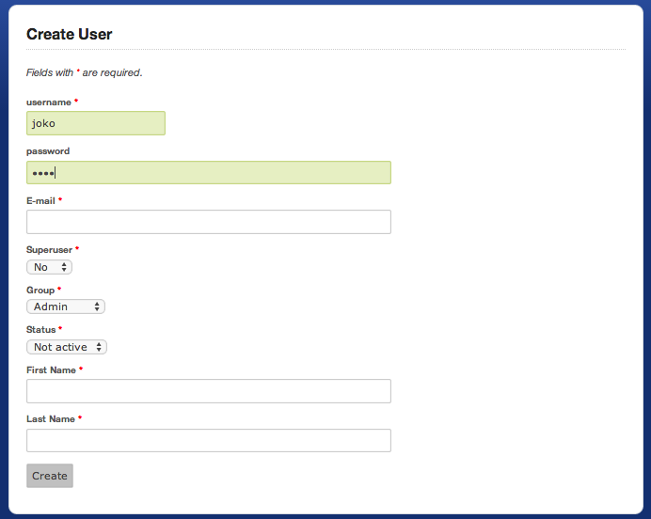

On that page, enter the information related to the new user to be created:

* **Username**: enter the user name/login info
* **Password**: enter the password
* **Email**: enter the user’s email
* **Superuser**: tick if user is a superuser
* **Group**: select the user’s group, user for regular user or root for administrator user
* **Status**: Active or Not Active. Not active users can not login to the system.
* **First Name** and **Last Name** is a profile field for first name and last name.

Click the **Create User** button to create the user.

# Manage Profile Fields

While logged in as admin user, you can change all other user’s profile fields. You can manage profile fields at the Manage Profile Fields link on the Manage users list.



A page like the following will appears:

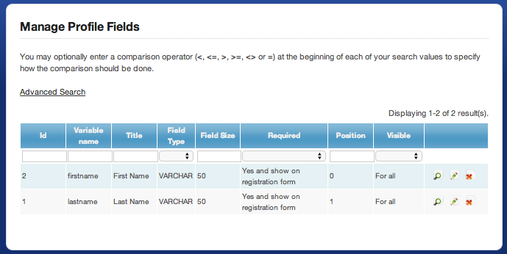

On that page, you can do several things:

* Add new profile field
* Change the name, label, type, size, required or not, position, visibility of the field

To update a profile field click on the Update icon on the Profile Field list, the following page will appears:

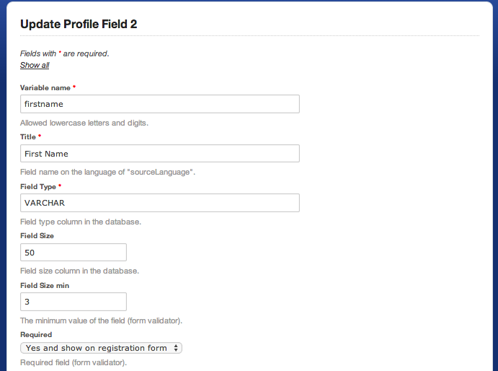

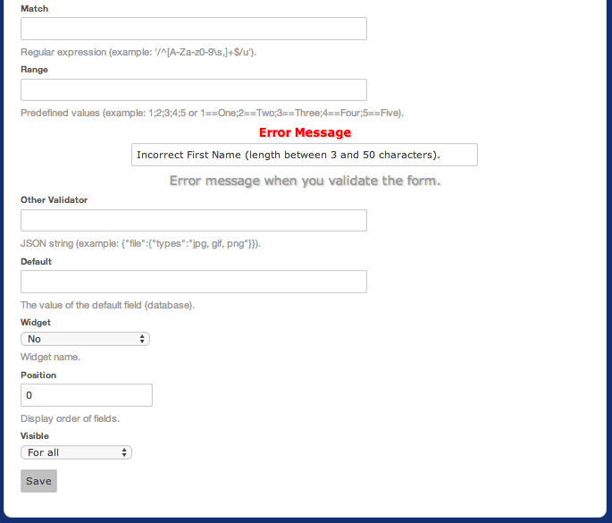

**Variable name**is the variable name. Allowed lowercase letters and digits.

**Title** is the field name.

**Field Type** is the field type column in the database.

**Field Size** is the field size column in the database.

**Field Size min**  is the minimum value of the field (form validator).

**Required** to set how required field behave.

**Match** is the Regular expression (example: '/^[A-Za-z0-9\s,]+$/u') content matching

**Range** is the Predefined values (example: 1;2;3;4;5 or 1==One; 2==Two; 3==Three; 4==Four; 5==Five).

**Other Validator** is any other validation rule, JSON string (example: {"file":{"types":"jpg, gif, png"}}).

**Widget** is the widget name to display the field.

**Widget Parameter** is the widget parameters, in JSON string (example: {"param1":["val1","val2"],"param2":{"k1":"v1","k2":"v2"}}).

**Position** is the display order of fields.

**Visible** is to set how the field will be visible.

Click Save button to save the profile field.